

**Department of Software Engineering**

**Faculty of Computer Science & Information Technology**

**The Superior University, Lahore**

**Name:** MUHAMMAD HAMZA ALI

**Roll No:** SU92-BSAIM-S24-032

**Section:** 3A

**Subject:** ARTIFICIAL INTELLIGENCE(LAB)

**Task No:** Mini Project 2(Lab Task-2)

**Mini Project-2**

**Movie Budget Analyzer**

**1. Introduction:**

* The Movie Budget Analyzer is a Python application designed to help users analyze movie budgets.
* It allows users to input movie data, calculate the average budget, and identify movies with budgets higher than the average.

**2. Features:**

The application provides the following features:

* **Add Movies:** Users can input multiple movies along with their respective budgets.
* **Calculate Average Budget:** The application computes the average budget of all entered movies.
* **Identify High Budget Movies:** It lists movies that have budgets exceeding the average budget, along with the difference from the average.
* **User Interaction:** The program interacts with users through command-line inputs and outputs.

**3. Implementation Details:**

The application is implemented in Python using a class-based structure.

* **Class Movies:**
* **Attributes:**
* **‘movie’:** A list of tuples containing movie names and their budgets.
* **Methods:**
* **‘__init__(self, movie)’:** Initializes the movie list.
* **‘cal_avg_budget(self)’:** Calculates and returns the average budget of the movies.
* **‘add_movie(self)’:** Prompts the user to add new movies and their budgets.
* **‘high_budget_movie(self, avg_budget)’:** Identifies and returns movies with budgets higher than average.
* **‘main(self)’:** Orchestrates the flow of the application, calling other methods as needed.

**4. User Interaction:**

* The application prompts users to enter the number of movies they wish to add.
* For each movie, users provide the name and budget.
* After adding movies, the application calculates and displays the average budget and lists movies with higher budgets.

**5. Code Structure:**

The main components of the code are:

* The main function of the application is encapsulated in the **‘main()’** method, which manages user input and output.
* The logic for calculating the average budget and identifying high-budget movies is modularized into separate methods for clarity and maintainability.

**6. Example Usage:**

* Users can start the application and input movies like:
* “Eternal Sunshine of the Spotless Mind” with a budget of $20,000,000.
* “Pirates of the Caribbean: On Stranger Tides” with a budget of $379,000,000.
* After entering the movies, the application will output:
* The average budget of the movies.
* A list of movies with budgets above the average, along with the budget difference.

**7. Output:**

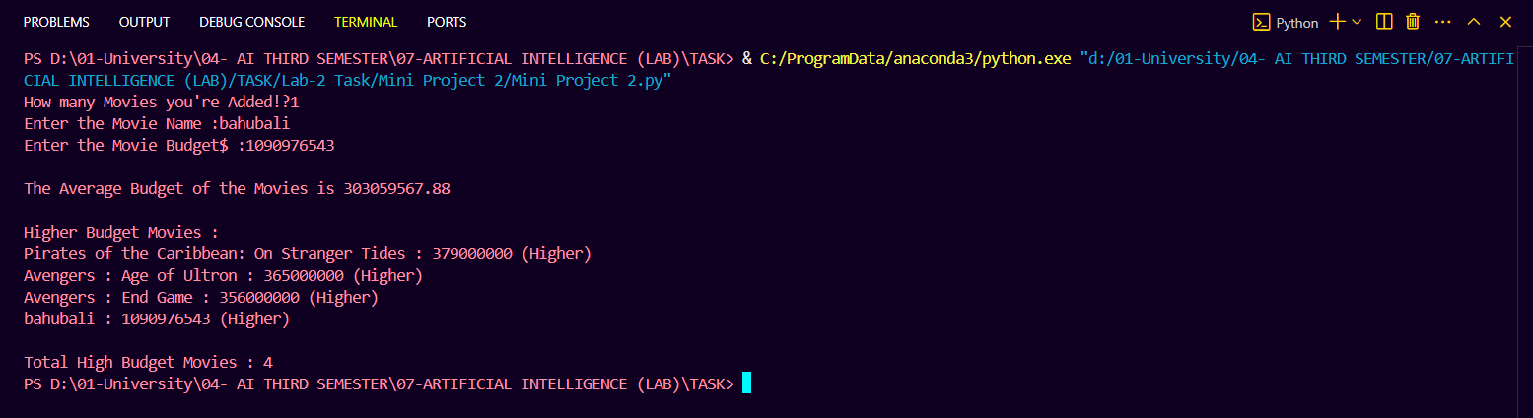

**8. Conclusion:**

* The Movie Budget Analyzer is a useful tool for movie enthusiasts and industry professionals to analyze and compare movie budgets.
* It demonstrates basic programming concepts such as classes, methods, and user input handling in Python.